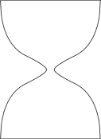
20.109: Abstracts & Titles
Exercise: Draft your Mod 1 Abstract

General background | Something everyone in your audience cares about.
Specific background | Zoom in from General Background to the thing you did.
Knowledge gap / Unknown | Question that will be answered by your research. Problem, phenomenon that is not understood.
HERE WE SHOW | Conclusion, answer to the Unknown
Results | Brief summary of approach + very high-level results.  Common pitfall = too much Methods/Results.
Implication / Significance | So what?  What do your results mean for the thing everyone cares about?  Next steps?

