Guide to Expectations for Professors, Instructors, and Teaching Assistants

Professor(s): Instructor(s):
TA(s):
Semester: Course:
Course meeting time/location:
Lab/discussion meeting time/location (if applicable):

This sample guide to expectations highlights some of the common responsibilities for graduate TAs. Use this document as a guide to discuss the TA responsibilities in more detail and add or remove additional requirements/expectations, as appropriate. The professors, instructors, and TAs should agree on the expectations for the TA appointment prior to the start of the course. Faculty advisors of the TAs should be included in the discussion as appropriate.
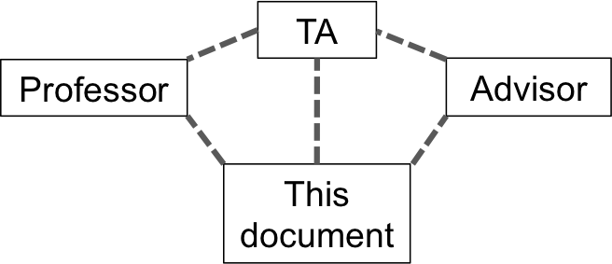

TA weekly hours and attendance | Notes:
Hours per week expected
Actions to take if weekly hours are not within this range
At lectures (all, some)
Take notes or will be given notes
Other

Class preparation | Notes:
Set up technology or demonstrations in classroom before lectures
Proctor exams (along or with other TAs, faculty)
Responsibility for creating exams, problem sets, assignments
Other

Administrative | Notes:
Keep class attendance
Maintain grade book
Manage online information (e.g., Stellar)
Other

Grading | Notes:
Specific grading responsibilities:
Exams (dates)
Assignments (dates)
Quizzes
Projects
Specific grading procedures (online submission?)
How will grading standards be explained? (rubric, guidelines)
Will faculty review TA’s grading prior to returning work to students?
Timeline for grading and returning work to students
Process for handling student grading complaints

Office hours | Notes:
Will TA hold office hours? Where? How often?
How is TA expected to conduct office hours? (explain, clarify, review homework)
Policies for notifying students in case of cancellation of office hours

Working with student issues | Notes:
What kinds of issues need to be reported to prof/instructors?
Policy for late assignments, extensions, absences
Procedures for ensuring academic honesty

Teaching methods | Notes:
Is TA expected to lecture? How often? Will faculty be present? Will TA receive feedback on performance?
Will TA review lecture plans with faculty prior to lecture?
Is TA expected to hold review sessions prior to exams?

Discussion/lab sessions (if applicable) | Notes:
Create a separate syllabus or lesson plan for the TA section?
Pre-established assignments? How much flexibility does the TA have in conducting the lab / discussion section?
Does the TA have autonomy to design their own activities or assignments? If yes, would they need to be reviewed by faculty? How soon in advance?
Maintain / obtain equipment

Communication with professor/instructors | Notes:
How frequently and in what form will you touch base (in person, email, regularly scheduled meetings, meetings as needed)?
How much advance notice is needed for time conflicts?

TA Teams (if more than one TA) | Notes:
Is there a “lead” TA? What is their role?
Will all the TAs meet regularly?
Policies for maintaining consistency among TAs assigned to various sections of the same course

Feedback and evaluation | Notes:
How do you best receive feedback? (both professors and TAs)
Professor observation of lecture or lab/discussion section
What does TA feedback look like? Professor feedback?
Schedule for feedback (midterm, end of term?)
Will there be separate student evaluation forms for lab/discussion sections?

Other responsibilities and notes:

Optional:

We have discussed the issues above and agreed upon the responsibilities of the TA position for this course.

Signature of Professor/Instructor(s) Date

Signature of Teaching Assistant(s) Date

